Kura Hulanda village

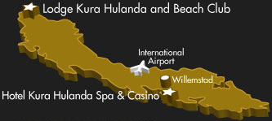

From the origin of man to West African empires…..
…… Through the middle passage to the Americas
Museum Kurá Hulanda is an anthropological museum that focuses on the predominant cultures of Curacao. It offers a world-class chronicle of the Origin of Man, the African slave trade, West African Empires, Pre-Colombian gold, Mesopotamian relics and Antillean art.
When you visit the museum the receptionist at the entrance will give you a map of the museum and will show you how to guide your walk through the museum. She will offer general information about the museum and can inform you about all the various items that are on sale in the Museum Shop.
For tours you can call the museum and appointments can be made so a guide (Papiaments, Dutch, English and Spanish speaking) can tour your group through the museum. Visitors who prefer to walk on their own and want some extra information, an audio guide (Dutch, English versions available) can be rented for a small amount at the entrance of the museum. For journalists a special press folder is available which includes several photographs of exhibit items.
For school children in need of some extra information for study purposes, a special information kit is available.
General Information
Opening Hours
Tuesday through Saturday from 10:00 a.m. till 5:00 p.m.
General fees
Adults: 15,- ANG. / $9-USD; Senior Citizens 9,-ANG. / $6-USD
Children (till 12 years old) 9,- ANG. / $6-USD; Students 13, -ANG. / $7-USD

Museum Shop
At the entrance of the museum, the Museum Shop sells various items -special designed T-shirts, polo shirts and caps, a beautiful poster - with the theme of the museum, various postcards of impressive collection items, a wide variety of CD's with African music from all over the continent, a large collection of African art - wooden masks, fertility dolls and sculptures from shona stone, musical instruments, djembe's and ballaphones, African games and much more.
From the origin of man to West African empires…..
…… Through the middle passage to the Americas
Museum Kurá Hulanda is an anthropological museum that focuses on the predominant cultures of Curacao. It offers a world-class chronicle of the Origin of Man, the African slave trade, West African Empires, Pre-Colombian gold, Mesopotamian relics and Antillean art.
When you visit the museum the receptionist at the entrance will give you a map of the museum and will show you how to guide your walk through the museum. She will offer general information about the museum and can inform you about all the various items that are on sale in the Museum Shop.
For tours you can call the museum and appointments can be made so a guide (Papiaments, Dutch, English and Spanish speaking) can tour your group through the museum. Visitors who prefer to walk on their own and want some extra information, an audio guide (Dutch, English versions available) can be rented for a small amount at the entrance of the museum. For journalists a special press folder is available which includes several photographs of exhibit items.
For school children in need of some extra information for study purposes, a special information kit is available.

Rhodes, Darwin, Stuyvesant and Vespucci were adventurers in the purest sense of the word, roaming the world yearning for discovery and knowledge. Jacob Gelt Dekker is the modern day equivalent with an entrepreneurial spin.
Through his adventures he has found his personal paradise, which his knowledge and experience permits him to present to the world through his creation of Project Kura Hulanda in Curacao.
In the past 10 years Jacob has been interviewed by many different magazines, newspapers, television, radio and on internet websites. Newspapers from Greenland, Magazines out of the U.S. or Television program's in Europe, a broad kind of media has wanted to know Jacob. Also his work, as an entrepreneur but mostly his work as an Philanthropist.
By all his traveling and his way of life, his broad knowledge and interference in world issues, Jacob have been invited for diverse media. Not only in the U.S. or the Netherlands but in all other parts of the world. Read more
The Story
Born in Oterleek in the Netherlands in 1948, Jacob Gelt Dekker's youth was chronologically the same as other children, but philosophically quite brief. Plagued by illness throughout his childhood, Jacob was driven to survive and not only beat the odds... Read more
The Author
On the third of October 2007, Jacob introduce his debute books: Persona non grata & Het doel heiligt de middelen. Read all about upcoming books or published books of Jacob... Read more
The Speeches
Selected Writings and Speeches; Luchtvaartnieuws, Conference of World Affairs, AABC, Benai Zion Congregation, ATIA & Budget defict vs. Balanced budget... Read More
The Entrepreneur
Jacob Gelt Dekker's entrepreneurial flare led him to open 120 one-hour photo shops in Europe, which he later sold to Kodak for an undisclosed sum. His other entrepreneurial successes include... Read more
The Explorer
Jacob officially retired in the late 1990s and wanderlust took hold. He traveled the world extensively for a combination of business and research. Jacob has circumnavigated the world more than 50 times... Read more
The Philanthropist
Jacob Gelt Dekker officially retired in the late 1990s and then poured his energy and fortune into creating the JADE Foundation, a non-profit organization dedicated to enhancing education... Read more

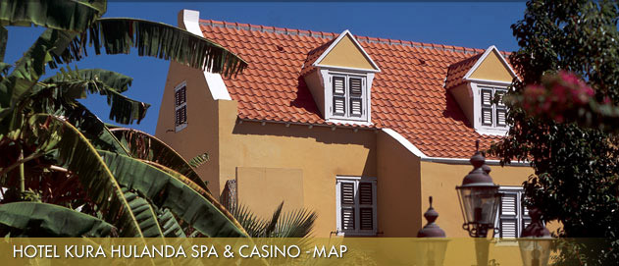

Hotel Map Legenda
1. Main Entrance
2. Parking
3. Bolivar Pools / Childrens Pool + Rooms 150-168 & 261-266
4. Santa Ana Bay + Rooms 175-187 & 275-285
5. Casino
6. Curacao Garden + Rooms 118-120, 122-126 & 220-226
7. Business Center
8. Bellevue Rooms + Rooms 127-129 & 131-132
9. Lobby & Rubens Salon
10. Shops
11. Marble Garden + Rooms 230-232 & 252
12. Fitness Center & Spa
13. Eco Pond Swimming Pool
14. Kura Hulanda Vacation Club and Real Estate Office
15. Village Square + Rooms 110-113, 119-121 & 210-212
16. News Café
17. Jacob's Bar & Terrace
18. Observatory Restaurant
19. Jaipur Restaurant & Bar
20. Sculpture Garden + Rooms 110-107 & 220-226
21. Museum
22. Conference Center
23. Museum Restaurant Kura Hulanda
24. Jacon Gelt Dekker Institute
25. Dialysis Center
. Ice machine

